Unit-1
- Which of the following statement is incorrect aboutelectrophiles?
- Electrophiles are positively charged or neutral species having vacantorbitals
- The electrophiles are attacked by the most electron-populated part of onenucleophile
- Chemical species that do not satisfy the octet rule such as carbenes and radicals are electrophiles.
- Electrophiles arelewisbases Ans-d

Which of the following is not anelectrophile?
a)(CH₃)₄N⁺
b) Cl₂ c)HBr
d)Br₂ Ans-a

In the given molecule where will electrophile willattack
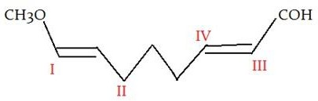

  - I
  - II
  - III
  - IV

Ans-a

- Which of the following is rate determining step in electrophilicsubstitution reaction?
- Generation of electrophile
- Attack by an electrophilic reagent on benzene ring c)Formation of product
d) All ofthementioned. Ans-b

Which of the following is most readily undergo electrophilicattack?
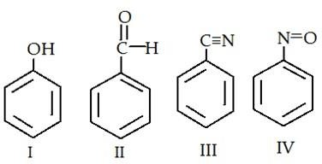

- I
- II
- III
- IV Ans-a

Which of the following act as catalysis in the nitration ofbenzene?
- Conc. HCl
- Dil.HCl
- Conc.H₂SO₄
- Dil.H₂SO₄ Ans-c

Fumingsulphuric acid is thesolutionof % SO₃ in conc. H₂SO₄.
- 10
- 9
- 8
- 7 Ans-d

Which of the following is the necessary condition fordesulphonation?
- Remove volatile hydrocarbon by steamdistillation
- Low concentration of water
- High concentration of sulphonatingagent
- A large excess of fumingsulphuricacid Ans-a

Which of the following act as electrophile inhalogenation?
- Nitroniumion
- Sulphoniumion
- Haloniumion
- Acyliumion Ans-c

Aromaticbromination catalyzed by the Lewis acid thalium acetategives

- Paraisomer
- Orthoisomer
- Metaisomer
- Para andorthoisomer Ans-b

The reaction in which benzene reacts with alkyl halide in the presence of alewis acid as a catalyst to produce alkylbenzene is knownas
- Nitration
- Halogenation
- Friedel-Crafts Acylation
- Friedel-CraftsAlkylation Ans-d

Which of the following is not a product of the reaction of benzene with CH₃Cl and AlCl₃?
- Toulene
- Isopropylbenzene

- O-xylene
- P-xylene Ans-b

The product of Friedel-Crafts Acylation reactionsare
- Alkylbenzene
- Alkylamine
- Arylketone
- Halobenzene Ans-c

How will you convert benzene into n-propylbenzene?
a)Friedel-Crafts Alkylation b)Friedel-Crafts Acylation
- Friedel-Crafts Alkylation followed by clemmensenreduction
- Friedel-Crafts Acylation followedbyclemmensenreduction Ans-d

Which one is not act as Neighbouring group
- O
- S
- N
- F Ans-d

TheNeighbouring group act as
- Internalnucleophile
- Externalnucleophile
- Both
- None Ans-a

Theshape of intermediate inNGP
- 3 or 5 membered cyclicintermediate
- 4 membered cyclicintermediate
- 3 membered cyclicintermediate
- None oftheabove Ans-a

The role of NGP in areaction
- Increase the reactionrate
- Carryout thereaction
- Decrease the rate of thereaction
- None Ans-a

NGP actas
  - annucleophile
  - anelectrophile

an internalnucleophile
  - anexternalnucleophile Ans-b

Acetolysis of 7-norbornenyltosylate is 1011 times faster than that of 7-norbornyl tosylate and it is due tothe
- Presence of bicyclicring

- SN2attack
- Presence of anchimericassistance
- Frontsideattack Ans-c

A low concentration of nucleophile favoursthe
  - SN2reaction
  - SN1reaction
  - Both SN1 and SN1reaction
  - None ofthementioned Ans-b

The rate of nucleophilic substitution reactions are higher in the presenceof

- Electron withdrawinggroups
- Electron releasinggroups
- Both electron withdrawing and releasinggroups
- None ofthementioned Ans-a

ChooseMichael addition reactions from thefollowing
- Diethyl malonate with methylcrotonate.
- Diethyl malonate with diethylfumarate.
- Mesityl oxide with diethylmalonate.
- alltheabove Ans-d

Michael additionmeans
  - nucleophilicaddition
  - electrophilicaddition
  - nucleophilicsubstitution
  - electrophilicsubstitution Ans-a

In Michael addition reaction the nucleophile actas
  - Michael donor it represents electron withdrawinggroup
  - Michael acceptor it represents electron withdrawing group
  - Michael donor it represents electron donatinggroup
  - Michael donor it represents electrondonatinggroup Ans-a

Find out the nucleophilic donor in Michaeladdition
- Cyanoacetamide b)acralidehyde
  - acrylonitrile
  - Chinnamaldehyde Ans-a

Find out the nucleophilic acceptor in Michaeladdition
  - acralidehyde b)Cyanoacetamide c)malonicester
- acetoaceticester Ans-a

28.C₆H₅CHO+ClCH₂COOC₂H₅ →?
  - α,β epoxyesters
  - α,β epoxyresins
  - Both2&b
  - None oftheabove Ans-a

Condensation of aldehydes and ketone into α,β epoxy esters in the presence of base is called as

  - Darzencondensation
  - darzen addition C)Claisenreaction
d)Michaeladdition Ans-a

The hydrolysis of glycidic estergives
  - glycidicacids
  - glycidylalcohol
  - Botha&b
  - None Ans-a

Darzen reaction undergo in the presence of
  - Base b)acid c)heat
d)light Ans-a
- The hydrolysis of glycidic ester reaction carried out in the presenceof a)Alkali
b)Base c)water
d)Acid Ans-a
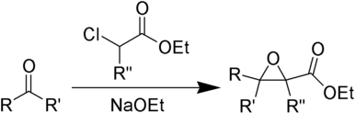

Mention the above reaction’s name
  - DarzenReaction
  - Wittigreaction
  - Wittig hornerreaction
  - Stobecondensation Ans-a

KCN 34.C₆H₅CHO+C₆H₅CHO →?
a) Benzoin b)aldehydes c)adduct
d)None oftheabove Ans-a

The first step of the Benzoin condensation ,benzaldehydeform
  - Cyanohydrin b)Cyanide C)Sodiumcyanide
d)Potassiumcyanide Ans-a

The order of decreasing stability of the following cationsis?
(I) CH₃C⁺HCH₃ (II) CH₃C⁺HOCH₃ (III) CH₃C⁺HCOCH₃
- III > II > I
- I > II > III
- II > I > III
- I > III > II Ans-c

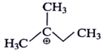
Which of the following is most stable intermediate?

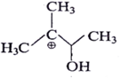
a)

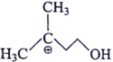
b)

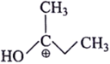
c)

d)

Ans :C

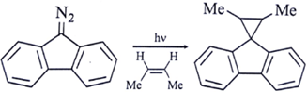
38.5. Which intermediate is involved in the reaction given below?
a) free radical b)carbene c)carbocation
d)caranion Ans-b

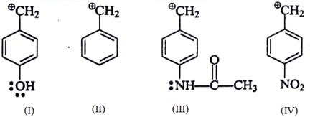
- Arrange the following intermediate into decreasing order of stability.

a)I>III>II>IV b)II>III>IV>I c)III>IV>II>I
d) I > III > IV > II Ans-b

- What is the correct decreasing order of stability of following cation?
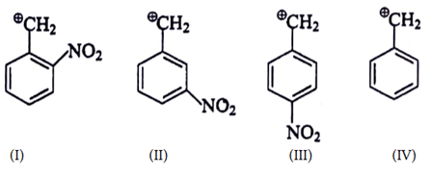

a)II>III>I>IV b)IV>II>III>I c)IV>III>I>II
d) III > I > II> IV Ans-b

What is the correct decreasing order of stability of following cation?
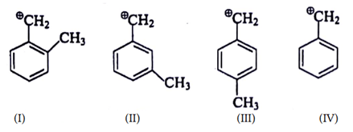

a)I>II>III>IV b)I>IV>II>III c)I>III>II>IV
d) IV > III > II > I Ans-c

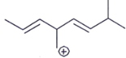
Which carbocation is the most stable?

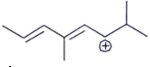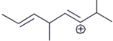a)

b)

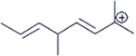
c)

d)

Ans:b

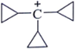
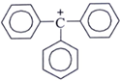
- Which one among the following carbocations has the longest half-life?

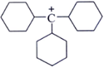
a) b)

c)

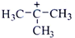
d)

Ans:a
- The general formula ofnitrenes
••
  - R-N: b)R-N₂
- R-NH
- None oftheabove Ans-a

Nitrenes are actas
  - anelectrophile
  - nucleophile
  - Catalyst
  - reactioninhibitors Ans-a

Pickout the most stableintermediate

  - Carbene b)Nitrene c)freeradicals
d)carbocations Ans-b

The reason for higher stability of Nitrene overcarbenes
  - large amount of 2s character in the orbital that is occupied by the lone pair of electrons innitrenes
  - Tripletcarbeneismorestablethansingletcarbenebecauseithastwounpairedelectrons
  - lower than singlet carbene and triplet carbene is present in ground state which is more stable than excited state but singlet carbene is present in excitedstate
  - alltheabove Ans-d

The most common methods of generating nitrenes
  - photolytic or thermaldecomposition
  - elimination c)rearrangement
d)pyrolysis Ans-a

carbenes are generatedfrom
  - diazoalkanes
  - photolytic,
  - thermal and transition metal-catalyzedroutes
  - alltheabove Ans-d

The formation of cyclopropane by the addition of carbenoids to an alkene or alkyne is called
  - simon-smith reaction b)Darzenaddition
- Michaelreaction
- 1,3 dipolaraddition Ans-a

The intermediate formed in simon-smithreaction
  - CH₂I₂
  - ZnI₂
  - I—CH₂Zn—I
  - Zn(Cu) Ans-c

The hybridization ofcarbene
  - sp2 b)Sp3 c)Sp
d)None Ans-a

pickout the addition reactions ofalkenes
- Electrophilic Addition of Hydrogen Halides....
- Addition of Strong Brønsted Acids. c)Electrophilic Addition of Halogens toAlkenes.
d)alltheabove Ans-d

Alkenes generally undergo
  - addition b)substitution c)elimination
d)None Ans-a

Hydroboration reaction isa
  - Oxidation b)reduction

- Redox
- None Ans-a

Hydroboration reaction isa
  - two-step hydration reaction that converts an alkene into analcohol
  - two-step hydration reaction that converts an alkene into analdehyde
  - two-step hydration reaction that converts an alkene into anketone
  - alltheabove Ans-a

Hydroxylation is
  - Oxidation
  - reduction c)Redox
d) None Ans-a

Hydroxylation reactionis
  - carbon–hydrogen (C-H) bond oxidizes into carbon–hydroxyl (C-OH)bond.
  - two-step hydration reaction that converts an alkene into analdehyde
  - two-step hydration reaction that converts an alkene into anketone
  - alltheabove Ans-a

Hydroxylation of alkenesis
  - anoxidationreactionwhereacarbon-carbondoublebondconvertstoacarbon-hydroxyl bond

bond

  - reduction of c=cbond
  - an oxidation reaction where a carbon-carbon double bond converts to aaldehyde
  - None Ans-a

The hybridization ofNitrenes
  - sp2
  - Sp3 c)Sp
d)None Ans-c

Unit 2

- Dicyclohexylcarbodiimide is act asa
  - Oxidizingagent
  - reducing agent c)catalyst d)None

Ans -a

- DCC oxidize alcoholinto
  - Primaryalcohols
  - Secondaryalcohols
  - carbonylcompound
  - None of theabove

Ans - c

3.RCOOH+R’OH+ ? →RCOOR,completethereactionwiththefollowing
- DCC
- LiAlH4
- NaBH4 d)SeO2

Ans –a

- TheroleofDicyclohexylcarbodimideinthereactionRCOOH+R’OH+ →
RCOOR
  - Dehydrating agent b)Oxidizingagent
- Catalyst
- none of theabove

Ans–a 5.RCOOH+R’OH+DCC →RCOOR,thecarboxylicacidact as
a) nucleophile b)Electrophile c)Catalyst d)None

Ans –a

- Pickout the product which occurred from oxidation reaction of Carboxylic acid to esters with the reagent of DCC+ DMSO + Aceticanhydride
  - amide
  - Dicyclohexylurea
  - Both a&c d)None

Ans – c

- The oxidation of methylene groupgives
  - carbonylcompounds
  - ester
  - alcohols
  - alltheabove Ans- c

The oxidation reaction of methylene group to carbonyl compound in the presenceof
  - Maganesesalts
  - cobalt salts c ) both a&b d)None

The oxidation of aryl methane reaction iscalled
  - Etardreaction
  - Oxidation of methylene reaction c)oxidation of olefin reaction d)None

The oxidation of Heterocyclic bound methyl groupgives
  - aldehyde
  - ester
  - alcohols d)none

Etard reaction will be done in the presenceof
  - chromylchloride
  - Magnesiumchloride
  - Copperchloride

Ans -c

Ans –a

Ans–a

d)none

Ans-a

- The oxidative cleavage of alkenegives
  - carbonylcompounds
  - ester
  - alcohols d)none

Ans –a
- For the effective oxidative cleavage of alkene is done at low temperature with the helpof
  - ozone
  - chromylchloride
  - copper chloride d)none

Ans –b 14.The oxidative cleavage of alkene treated with dimethyl sufide to give the product
a)aldehyde b)Ketone c)Both &c d)none

Ans-c

- Pick out which is not an oxidizingagent
- LiAlH4
- DMSO c)DCC
d) SeO2

Ans- a

- The product of Ozonolysisis
  - aldehyde andketone
  - primary alcohol c)secondaryalcohol
d)ester Ans–a

In ozonolysis, disubstituted alkenecarbon
  - oxidatively cleaved to ketone b)oxidatively cleaved to aldehyde c)oxidatively cleaved toformaldehyde d)None

Ans-a

- In ozonolysis, monosubstituted alkenecarbon
  - oxidatively cleaved to ketone b)oxidatively cleaved to aldehyde c)oxidatively cleaved toformaldehyde d)None

Ans- b

- In ozonolysis, unsubstituted alkenecarbon

  - oxidatively cleaved to ketone b)oxidatively cleaved to aldehyde c)oxidatively cleaved toformaldehyde d)None

Molecular formula of DCC oxidizingagent
a)(C₆H₁₁N)₂C
- C21H20O4
- C20H30O2
- C31H20O2

The structure DCC seemslike
  - allene b)alkene c)benzene d)None

The symmetry ofDCC
  - C₂ b)C₃V C)C₂V
d)None

Gilman’s reagent is
  - oxidising agent b) reducing agent c) catalystd)None

Ans-c

Ans-a

Ans-a

Ans-a Ans-a

- Gilman’s reagent is
  - R₂CuLi
  - R₃CuLic)RCuLi d)none

- R₂CuLi is generally usedfor
  - oxidising α,β unsaturated compounds b)reducuing α,β unsaturated compounds c)redoxreaction
D)none

The oxidation of olefinic double bonds results in the formationof
  - epoxide b)aldehyde c)ketone d)None

OsO₄is an
  - Dehydratingagent
  - Oxidizingagent
  - Catalyst
  - none of theabove

OsO₄is react with Me₃CNH₂itgives

Ans-a

Ans-a

Ans-b

Ans-b

  - imidoderivative
  - nitride derivative c)diols
d)none

OsO₄is react NH₃ itgives
  - imidoderivative
  - nitride derivative c)diols
d)none

Oxidation of alkenes with OsO₄ gives
  - Diolb)aldehyde c)ketone d)None

Ketones react with the reducing agent tomake
  - primary alcohols b) secondaryalcohols
c)tertiaryalcohols d) aldehydes

The reducing agent used for the reduction of ketonesis
  - tetrafluorate b) tetra hydridoborate
c) tetraflouroborate d) tetrachloride

The polar nature of Carbonyl group in ketone is dueto
  - very less electronegativedifference
  - very large electronegativedifference
  - presence ofhydgrogenbonding d) None

Phenonesare

Ans-a

Ans-b

Ans-a

Ans -b

Ans -b

Ans - b

  - aldehydes in which carbonyl group is attached with benzyinering
  - ketone in which carbonyl group is attached with benzenering
  - phenols in which carbonyl group with alkylgroup
  - Phenols in which carboxylic acidgroup

Ans - b

- In 4 - tertiary butyl cyclohexanone compound the 3º-butyl gp ispresentin position

  - axial b)equatorial c) a&b d) None

Ans - b

- In reduction of 3º-butyl cyclohexanone which is the majorproduct?
  - trans isomerb)cisisomer c) symmetric compoundd)None

Chlorineis
  - oxidizingagent b) bleachingagent
c)Disinfectant d) All theabove

38.A reducingagent
a)gainselectrons b) loseselectrons
c) both a&b d) None

39.A reducing agents gets

a)Oxidisel b)reduced c) both a & b d)None

Which of the following is not a reducing agent?
  - CO₂ b)SO₂ c) NO₂ d) ClO₂

The reduction is the decrease in
  - Oxidationnumber b)charge c)Solubility d)None

Ans - a

Ans -d

Ans -b

Ans -a

Ans -a

Ans -a

- LiAlH₄& NaBH₄ are serving as a source of hydride ion due to the presenceof
  - a polar metal -metalbond b) a nonpolar metal - hydrogenbond
c) a polar metal -hydrogenbond d) None

LiAlH4 converts Carboxylic acidsto

  - aldehyde b)ketone c)2ºalcohol d) 1ºalcohol

LAH reducesamides
  - acid b)alcohol c)animies d) None

Ans -c

Ans -d

Ans - c
- LAC reduces quartinary ammonium cations into
  - 1ºammoniumcation b)2ºamines c)tertiaryamines d) None

Ans - c

- NaBH4 can be purified by recrystallization from50ºC
  - DCC b)dithiane c)diglyme d) LAH

is used to reduce foxing in old books and documents
  - LAH b)Sodiumborohydride c) DIBAL d)Acetone

Structure for tri tertiary butyl oxyaluminium hydrideis

Ans -c

Ans -b

Ans - a

- Tri TBAH converts acid chloride into
  - alcohols b)aldehydes c)ester d) None

Sodium cyanoborohydride used in the reductionof
  - acids b)aldehydes c)ketones d)imines

Ans -b

Ans -d

- Whatiselectionwithdrawingsubstitutentpresentinsodiumcyanoborohydride

  - borane b)hydride c)cyanide d) None

cause eye burns &wheezing
  - LiAlH₄ b)NaBH₄ c)NaBH₃CN d)None

Tri alkyltin hydride converts organic halides into
  - ketones b)alcohols c)acid d)hydrocarbon

is used as foamingagent
  - borazine b)benzene c)hydrazine d)None

Ans -c

Ans -c

Ans -d

- is used as a rocketfuel
  - fluorine b)Neon c) Argon d)hydrazine

Hydrazine as a fuel react and forms a safe solidcalled
  - hydrazoneb)hydrazil c)dihydrazine d)hydrazal

The first rocket propellent used in world warII is
  - ethanal b)hydrogenperoxide c)hydrazine d) None

Hydrazine is preparedby
  - oxidationprocess b) isomerisationprocess
c)peroxideprocess d) redox process

On reduction using hydrazine the by productsare
  - H₂&N₂ b) N₂&O₂ c) N₂gas&Water d) Nitrousoxide&Water

Hydrazine is usedin
  - wolf -kishnerreduction b) Sand meyarreaction
c)Cannizaroreaction d) None

Ans -c

Ans -d

Ans -a

Ans -c

Ans -c

Ans -c

Ans –a

Unit-3
- Which type of isomers are formed in rangementreactions
  - Structuralisomers b) Geometricalisomers
c)OpticalIsomers d) ConformationalIsomers

Ans - a

- Which intermediate Carbocation is more stable in Pinacol - Pinacolonerearrangement?
  - 1º b)2º c)3º d) 4º

Ans - c
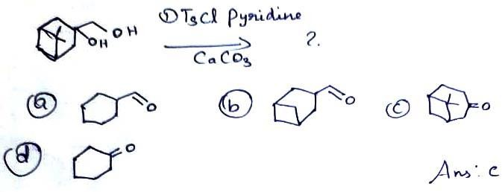3.

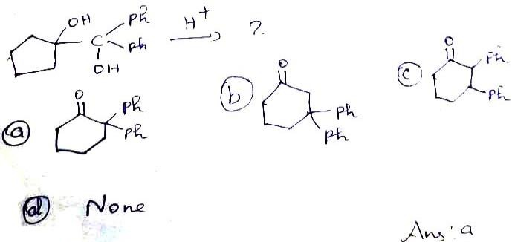4.

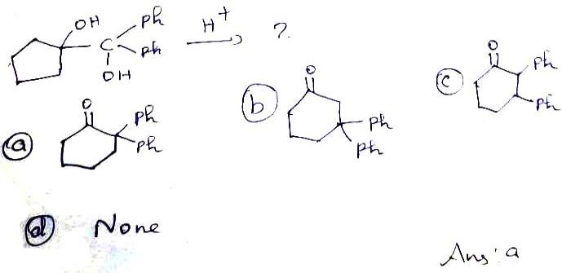5.

Pinacol - Pinacolone rearrangementis
  - Intramolecular b) Inter molecular
c) Nonregionselective d) All theabove

Ans - a
- The Vicinal diolscan be converted in to ketones (or) aldehydes by rearrangement
  - Hoffmann b)Pinacol-Pinacalone
c)Favorskii d) Reformatsky

Wagner Meerwein rearrangementinvolve
  - ClassicalCarbocation b) Non Classical CarboCation
c)Nitrene d) Carbene

CH₃ CH₂ Br+AlBr₃ ?
  - CH₃ - CH - CH₃ b) CH₃ CH₂CH₂CH₂ Br Br
c) CH₃ CH₂CH₂=CH₂ d) CH₃ CH = CH CH₃

Ans -b

Ans -b

Ans -a

- 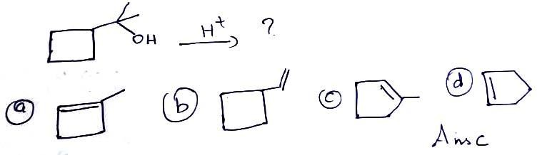10.

- 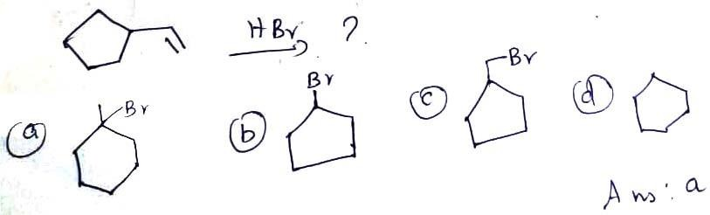11.

The intermediate in the favorskii rearrangementis
  - Nitrene b)benzyeme c)dioxigen d) cyclicpropanone

Ans - d

- Which is the first molecular rearrangement identified as such by earlychemists?

  - Wolffrearrangement b) Pinacol - Pinacolonerearrangement
c)Favorskiirearrangement d) Hoffmannrearrangement

Which Intermediate is formed in Wolff’sreaction?
  - Carbene b)Ketene c)CarboCation d)Carbanion

Ans -b

Ans -b

- The Rearrangement involve the formation of cyclopropanone intermediateis?
  - Pericyclicreaction b) Favorskiirearrangement
c)Beckmannrearrangement d) Hoffmann rearrangement

In which medium Favorskii rearrangementoccurs?
  - Acidic b)Basic c)Alkaline d)Neutral

Ans -b

Ans -b

- Which type of Catalylic reaction does Dienone - phenol rearrangementbelong?
  - AcidCatalysed b)BaseCatalysed c)Acidic d)Neutial

Ans - a

- Cine susbstitution involvedin
  - Beckmannrearrangement b) Favorskiirearrangement
c)Von-richterrearrangement d) Pinacol - Pinacolonerearrangement

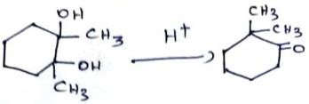This reactionrepresent

  - Pinacol -Pinacolonerearrangement b) Beckmannrearrangement
c) Benyzil -Benyzilirearrangement d) Curtiusrearrangement

What is the application ofPinacolone?
  - Used in pesticides, fungicides andherbicides
  - Used to prepare Pinacidildrug
  - Used to prepare Stiripentol&Triadimefon d) All theabove

Ans -c

Ans -a

Ans -d

- In Baeyer - Villiger rearrangement used to convert Ketone toester
  - Peroxyacid b) Trifluoro aceticacid
c) Meta chloro perbenzoicacid d) All theabove

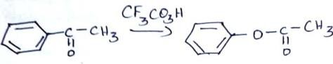This reactionrepresents

  - Schmidtrearrangement b) Baeyer Villigerrearrangement
c)Clemmensenreduction d) Favorskiirearrangement

What is the importance of Baeyer - Villigeroxidation?
  - Synthesis of lactones from mesomericcyclohexanones
  - Synthesis of Zoapatanol

Ans -d

Ans -b

  - Transformation of the steroiddehydropiandrosterone to anticancer agent test lolactone

  - All theabove

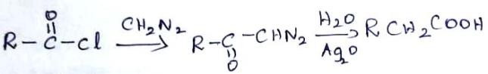This reactionrepresents

  - VonRichterrearrangement b) Wolffrearrangement
c)Clemmensenreduction d)Schmidtrearrangement

Pinacol - Pincoloneinvolves
  - 1,2 Shift b) 1, 3shift c) 1,4 shift d) 1, 5shift

Ans -d

Ans -b

Ans -a

- Which accompanying 1, 2 rearrangment in wolff rearrangement when αdiazocanbonyl→ ketone bylossof compound
  - Dioxygen b)Dinitrogen c)disulphur d) Ammonia

Driving force of Dienone phenol rearrangementis
  - acidity b)basicity c)Aromaticity d)None

Ans -b

Ans -c

- Which reagent is a goodnucleophile
  - NH₃ b)BH₃ c)Br₂ d)HBr

per acids areusedin rearrangement

Ans - a

  - BaeyerVilliger b) Pinacol-Pinacolone c)Bekmann d) None

Ans - a

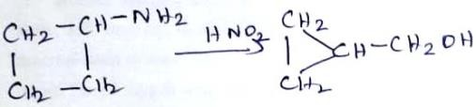
- This reaction iscalled

  - wittingreaction b) WagnerMeerwein
c)Demjanovrearrangement d) curtius

Conversion of isoborneol tocompheneis rearrangement
  - WagnerMeerwein b) curtius
c)Hoffmann d) perkingreaction

Compheniol to sateneisa rearrangement
  - curtius b) Beckmann c) Demjanov d) Wagnermeerwein

Conversion of αpinene tocompheneis rearrangement
  - curtius b) Beckmann c)Demjanov d) Wagnermeerwein

Ans -c

Ans -a

Ans -d

Ans -d

- ConversionofIaminomethylcycloalkanoltoenlargedcycloketoneisdoneby
rearrangement
  - Demjanov b) TiffeneauDemjanov
c)Curtius d) Pinacol -Pinacolone

Ans - b
- In Demjanov rearrangement ring contraction & ring expansion is not possibleIf
is present
  - enclocyclicorientation b) exo cyclicorientation
c) both a&b d) None

Ans - b

- In Demjanov rearrangement ring expansion ispossibleof ispresent
  - enclocyclicorientation b) exo cyclicorientation
c) both a&b d) None

Wagner meerwein rearrangement was first discoveredin
  - alicycliccompounds b) tetra cyclic compounds
c)bicyclicterpenes d) aromaticcompounds

Ans -a

Ans -c

- Ketone can be converted to esters by using peroxyacidsin rearrangement
  - Favorskii b)claisen c)BayerVilliger d) WagnerMeerwein

Ans - c
- The conversion of 4, 4 - disubstitutedcyclohexadienone to stable 3,4 disubstituted phenol in presence ofacidis rearrangement
  - BaeyerVilliger b) Wagner Meerweinc)Curtius d) Dienone -Phenol

Santonni→deisotopesantoninis rearrangement
Ans - d

  - BaeyerVilliger b) Wagner Meerweinc)Curtius d) Dienone -Phenol

Ans - d

- An example of favorskii rearrangementis
  - Synthesisofterpenes b) Synthesis of steroids
c) SynthesisofAlkaloids d) Synthesis of cubane

Trimethylene methane cycloadditionisfollowing rearrangment
  - Favorskii b)claisen c)BayerVilliger d) WagnerMeerwein

In photo favorski rearrangement the protecting group usedis
  - P-hydroxyphenacylgroups b) α-hydroxyphenacylgroups
c)phenacylgroups d) None

Ans -d

Ans -a

Ans -a

- TheFavorskiirearrangementinthecaseofcyclicα-haloketonesconstitutes

  - ringexpansion b)ringcontraction c) both a &bd) ringopening

Ans - b

- TheearlierdaysBaeyer-VilligersuggestedthattheintermediateinBaeyer-Villiger rearrangementis
  - dioxygen b)dinitrogen c)dioxirane d) dihydrogen

Ans - c
- NowadaystheintermediateacceptedinBaeyer-Villigerrearrangementis
  - Oxirane b)Criegee c)dioxirane d)None

Migratory aptitude in Baeyer - Villiger rearrangementis
  - p-anisyl> p-tolyl> phenyl > p-chlorophenyl>pnitroPhenyl
  - p-anisyl< p-tolyl< phenyl < p-chlorophenyl< p-nitrophenyl
  - Phenyl >p-anisyl......... d) p-chlorophenyl<phenyl.......

(3R)-3-methylpentan2-one→(2R)-butan-2yl-acetateis rearrangement
  - Baeyervilligerarrangement b)curtius c)Stevens d) wolff

Ans -b

Ans -a

Ans -a

- Ketene intermediate is wolff rearrangement are well knowntoundergo with olefins
  - [2+3]thermalcycloadditions b) [2+2] thermalcycloadditions
c) [3+3]thermalcycloadditions d) None

Ans - b
- Conversionofquaternaryammoniumsaltsandsulfoniumsaltstoanimesandsulfides is known as rearrangement
  - curtius b)wolff c)stevens d) BaeyerVilliger

is the base used in stevensrearrangement
  - 3oammoniumsalts b) Benyzlicquarternery ammoniumsalts
c) both a&b d) None

The stevens rearrangement is a useful synthetic methodfor
  - Carbene insertion into a -s bond b) Nitrene insertion into c-sbond

Ans -c

Ans -b

c) Carbene insertion into ac-cbond d)None

Von - richter rearrangementis
  - Nuecleophilic aromaticsubstitution
  - Electophilic aromaticsubstitution
  - Nucleophilic aliphaticsubstitution d)None

Ans -a

Ans -a

- Carboxylation of para or meta substituted aromatic nitro compounds with KCN inan alcoholic solution of KOH. This is thereactionof rearrangement
  - Curtius b)Wolff c)Stevens d) Von -Richter

Ans - d

- Pinacidil ispreparedby rearrangement
  - Curtius b)Wolff c)Stevens d) Pinacol -Pinacolone

The drug prepared by Pincol - Pinacolone rearrangementis
  - Stirpentaol b)terpeniol c)Cubane d) Penicillin

Stevens rearrangement isoccurredin medium
  - acid b)base c)Neutral d) All theabove

The bio synthesis of human car nitrine isdoneby rearrangement
  - curtius b)stevens c)Wolff d) None

The substrate for the bio synthesis of human carnitrineis
  - octonium b)califorinium c)meldonium d)None

Ans -d

Ans -a

Ans -b

Ans -b

Ans -c

- The conversion of diayocarbonyl compound to ketene isrearrangement
  - wolff b)curtius c)stevens d)Beckmann

Ans : a

Unit-4
- The Phenomenone or process by which imines are converted in toenamine
  - imination b)Enamination c) amiimation d)Tautomerism

Enamine shows which type of behavior?
  - basic b) Electrophilic andacidic
c) Nucleophilicandbasic d) Nucleophilic

Ans -d

Ans -c

- Whatisthenameofthecompoundformedwhenalkylationofenamineisfollowedby hydrolysis
  - Carboxylicacid b)ketone c)Amide d)Ester

Which cyclic ketone enamine is mostreactive
  - fivemembered b) six membered
c)sevenmembered d) eightmemebered

Alkyl halides can be converted in to Grig nard reagentsby
  - boiling them with Mg ribbon in alecholicsolution
  - warning them with Mg powder in dryether
  - Refluxing them with Mg Cl₂sollution
  - Warming the with Mgcl₂

Which is not present in Grignardreagents?
  - Melthylgroup b) Magnesiumc)Halogen d) -COOHgroup

Ans -b

Ans -a

Ans -b

Ans -d

- Whichofthefollowingcompoundsdoesnotgiveatertiaryalcoholuponreactionwith methyl magnesiumbromide?
  - 3-methylpentanal b) ethylbenzoate
c) 4,4 - dimethylcyclohexanone d) 4 - heptanone

Ans - d

- Which of the following compounds gives a secondary alcohol upon reaction with methyl magnesiumbromide?
  - bulylformate b)3-pentanone c)Pentanal d) Methylbutanoate

Ans - c
- WhichisgivingprimaryalcoholuponreactionwithPhenylmagnesiumbromide?

  - 2-methyloxirate b) ethyleneoxide
c)ethylformate d) Carbondioxide

Ans - b

- Which of the following reagents, when treated with Phenyl magnesium bromide followed by acid work up, will yield 2-phenylethanol?
  - ethanol b) diethyletherc)ethanal d) oxirane

Identify the incorrect statement regardingalkadiene
  - These are a cyclicacids
  - These are unsaturatedhydrocarbons
  - These compounds have only one c = cbonds
  - These have general formulaCnH2n-2

Alkadienes are classified in to -types
a)1 b) 2 c)3 d) 4

Which is the perfect example for isolated doublebond?
  - 1, 4 -pentadiene b) 1, 2 -pentadiene
c) 1, 3pentadiene d) 1, 5 -pentadiene

Ans -d

Ans -c

Ans -c

Ans -a

- Conjugated diene reacts with which among the following to form a cyclohexene?
a) Phenol b) Dienophile c)Hexane d) Tribromo phenol

Ans - b
- Identify the statement which is related to Diels - Alder reaction?
  - It is verystereospecific
  - Molecular distortion takesplace
  - Cyclicdienes react very slower than the linear chaindienes

  - Addition maleic anhydride to cyclopentadiene causes diene and dienophile to produce differentproducts

Ans - c
- Which of the following reagents is required in the synthesis of alkenes by witting reaction
  - H₂NNH₂ b)B₂H₆ c)(C₆H₅)₃P d) (C₂H₅O)₃P

Robinson annulation is an extra ordinary important synthesis ofthe
  - three memberedring b) five memberedring
c) sixmemberedring d) four memberedring

Robinson Annulation is also used forsynthesizing
  - aliphaticcompounds b) aromaticcompounds
c)aldehydiccompounds d) spirocycliccompounds

Ans -c

Ans -c

Ans -d

- The synthetic outcome of a Micheal addition and subsequent intra molecular aldol condensation is calleda
  - Cannizaroreaction b) ClaisenSchimidtreaction
c)Aldolcondensation d) Robinson Annulation

The term annulation standsfor
  - breakingaring b) building aring
c) Ionisingaring d) Aromatising aring

The art of synthetic planning starts with the final productis
  - Metathesis b)Retrosynthesis c)Synthesis d)Carbonation

The symbol of retro synthetic arrowis
a)→ b) ↔ c)⇒ d) ≈

The molecule whose synthesis is being planned iscalled
  - Finalmolecule b) End productc) Starting Compound d) Targetmolecule

Ans -d

Ans -b

Ans -b

Ans -c

- Synthons are
  - positively chargedb) negatively charged c) Neutrald) both a &b

A reagent carrying out function of a synthon iscalled
  - equivalent compound b) syntheticequivalent
c)Targetmolecule d) syntheticreagent

Ans - d

Ans -d

Ans -b

- An analytical operation involves bond breaking so as molecule converted in to probable starting compound iscalled
  - Disconnection b) probagation
c)disproportion d) FGI

Ion produced by disconnection arecalled
  - Syntheticequivalent b) Targetmolecule
c)Synthons d)Reagent

Ans -a

Ans -c

- involveswritingonefunctionalgroupforanothersodisconnectionbecomes possible
  - disproportion b) functional groupinterconversion
c)Resonance d) Tautomerism

The FGI of cyclopentyl methanol willbe
  - Primaryalcohol b) SecondaryAlcohol
c)TerritaryAlcohol d) None

Grignard reagent react with formaldehyde toform
  - Primaryalcohol b) SecondaryAlcohol
c)TerritaryAlcohol d) None

The Synthon of cyclopentyl methanolis
Ans -b

Ans -a

Ans -a

a) _
CH2
c) d) -
_______
_______
________
b) _
CH2
+
+

Ans - d
- Thebestmethodforpreparationofα,βunsaturatedaldehydeorketoneis
  - Canninzaroreaction b) Claisen condensation
c)Aldolcondensation d) Perkin reaction

The starting material for synthesis of 2 -butenal
  - acetone b)acetaldehyde c)formaldehyde d)benyaldehyde

Acetoacetic ester is condensation productof
  - MethylCyanide b)acetone c) ethylpropanoate d) ethylacetate

Which of the following statements best describe asynthon?
  - Synthetic reagent used in areaction
  - A key intermediate in a reactionsequence
  - A transition state involved in a reactionmechanism
  - A hypothetical structure that would result in a given reaction if itexisted

BOC is used toprotect
  - Carboxylicacid b) hydroxylgroup
c)Aminogroup d) Carbonylgroup

Which of the following act as umploungreagent?
  - 1,3dithianes b)cyanide c)NitroCompound d) All ofthese

The site of disconnection is shownby
  - Wiggly line b) doubleheadedarrow c)Hollowarrow d) Ray

Which amine is not use for the synthesis ofenamine?
  - Pyrrolidin b)Morpholine c)Piperidine d) Methylamine

Ans -c

Ans -b

Ans -d

Ans -d

Ans -c

Ans -d

Ans -a

Ans -d

- Stabilisedylidereactswithaldehyde(ror)ketoneandproduces kind ofalkene?

  - cis(z)alkene b) Trans(E)alkene c)Conjugatedalkene d)None

The Synthetic equivalent for the following synthonis
  - 2-alkyl epoxide b)epoxide c)ketone d) haloalcohol

Ans -b

Ans -a

- A reaction which predominantly produces one of several possible structural isomer is called
  - Regioselectivity b)Stereoselectivity c) chemoselectivityd) All ofthese

DIBAL-H at low temperature reduces Lactonesto
  - lactols b)aldehydes c)acetaldehyde d) animoacid

On treatmentwithDIBAL-H yields dodecanal at195k?
  - CH₃CH=CHCH₂CN b)C₂H₅CN
c)CH₃(CH₂)₁₀COOCH₃ d) C₆H₅CN

is used in gas chromatographyanalysis
  - DIBAL b) DCC c)TMSI d) None

One of applications of TMSIis
Ans -b

Ans -a

Ans -c

Ans -c

  - cleaning b)purifying c) removing the BOCprotectinggroup d) None

Ans - c

- is a classical inhibitor of ATPsynthesis
  - DIBAL b) DCC c)TMS d) None

Ans - b

- causes skinrashes
  - DCC b)TMS c) DIBAL d) None

DIBAL isa
  - electophilicreducingagent b) Nucleophilic reducingagent

Ans - a

c)Oxidizing agent d) None

is used cocalayst for the polymerization ofakenes
  - TMS b) DCC c) DIBAL d) None

Phosphorus ylidesare
  - Lewisacid b) Lewis base c)Bronstedacid d) None

Phosphorus ylide is usedin
  - DielsalderCondensation b) Hoff mannreaction
c)Wittingreaction d) None

Inwittingreaction is anintermediate
  - oxaphosphethane b)Phosphonium c)Alkoxide d)Akyne

Sulphurylidesare
  - Zwitter ioniccompoundsb) Electophiles c)Nucleophiles d)None

umploungmeans
  - isomer b) explosive c)polarcompound d) polarity inversion

Ans -a

Ans -c

Ans -b

Ans -c

Ans -a

Ans -a

Ans -d

- If we use enamines to alkylate carbonyl compoundsis that is not required
  - Strong Acid b)StrongBase c)WeakAcid d) Weak base

The goal of retro synthetic analysis isa
  - isomeriation b) Cyclisationc) Structural Simplification d)None

What is grignardreagent
  - AlkylMagnesiumhalide b) Aryl Magnesiumhalide
c) both a&b d) None

Ans -b

Ans -c

Ans -c

- Tri methyl iodide structureis

  - Me
⏐
Me-Si- I
⏐
Me

Me
c) ⏐
Me-S- I
⏐
Me
b) _

d) None
__
I
⏐
Me-Si- I
⏐
Me

Ans - a

- DIBAL is
  - Diazo Butylaluminiumhydride b) Diiso butyl aluminiumhydride
c) Diiso butylaluminiumhydrate d) None

Ans – b

Unit -5

- Write the formula ofimidazole
  - C₃N₂H₄ b)C₄NH₃ C)C₃N₃H₂
d)C₄NH₅ Ans-a

The type of hybrization present in imidazolering
  - Sp2
  - Sp3
  - Sp
  - None Ans-a

Which Heterocyclic compound present in the anti-fungal drugclotrimazole
a)imidazole b)Thiazole c)Oxozole
d)None Ans-a

When Imidazole ring fused with Pyrimidinering
a)pyrrole b)benzimidazole c)Purine
d)Azepine Ans-c

Imidazole exists in how many tautomericforms
a)4

b)3
- 2
- 1 Ans-c

Imidazole is an exampleof
a)1,2-Azoles b)1,3-Azoles c)1,4-Azoles
d)1,5-Azoles Ans-b

Alkyl Nitriles produce Imidazole derivatives in the presenceof
  - Dimethylamine
  - 1,2ethanediamine
  - Methyl ethylamine
  - Phenylethylamine Ans-b

Which of the following is not true about the five memberedrings?
- Five membered rings are more stable than 4 memberedrings
- Five membered rings are more stable than 6 membered rings
- Five membered rings are more stable than 7 membered rings
- Five membered rings are more stable than 8memberedrings Ans-b

The molecular formula ofoxazole
  - C₃H₃NO b)C₄NH₃ C)C₃N₃H₂
d)C₄NH₅ Ans-a

Which of the following statements about oxazole, a heterocyclic aromatic compound, is true? Select any and all thatapply.
a) Both lone pairs on the oxygen atom are involved in the pi system that makes oxazole aromatic.
b. The nitrogen lone pair is part of the pi system that makes oxazole aromatic.
c. Oxazolo is planar.
d) There are 6 Pi electronsinoxazole Ans-d

The hybribization of Nitrogen in Oxazole
  - Sp2
  - Sp3
  - Sp
  - None Ans-a

The molecular formula ofThiazole
  - C₃H₃NS b)C4NH3C)C3N3H2
d)C₄NH₅ Ans-a

The hybridization of Nitrogen in thiazoleis
  - sp²hybridized b)Sp3
- Sp
- None Ans-a

Flavones are widely presentin

  - leaves asglucosides
  - flowers asglucosides
  - fruitsasglucosides
  - alltheabove Ans-d

The general formula offlavone
  - C15H10O2b)C20H10O2c)C30H10O2
d)C₁₀H₁₀O₂ Ans-a

synthesis offlavones:
  - Allan–Robinson reaction b)Auwers synthesis
- Baker–Venkataramanrearrangement
- alltheabove Ans-d

Wessely–Moser rearrangementis
  - methoxygroups to phenolgroups
  - ethoxygroups to phenolgroups
  - methoxy groupoxidation
  - methoxygroupreduction Ans-a

Anthocyannin isa
  - flavone b)flavonoid
- pigment
- a&c Ans-d
- Anthocyannin occurs in
a)tissues of higher plants b)leaves
- stem,root ,flower andfruits
- alltheabove Ans-d

Anthocyannins are generally usedas
  - p H indicator
  - used in organic solarcells
  - as a foodcolourant
  - alltheabove Ans-d

Antho means
  - flower b)stem c)fruit
d)glycosides Ans-a

The number of steps available in the synthesis ofpyrimidine
  - 6
b)5
- 4
- 3 Ans-a

Pyrimidinecontains
- cytocineonly

- uaracilonly c)a&b
d)none oftheabove Ans-c
- The formula ofpyrimidine
a) C₄H₄N₂ b)C₄H₄N₄ c)C₆H₆N₂
_{d)}C₄H₄N₃ Ans-a

Pyrimidine contains Nitrogenat
a)1,3
b)1,2
c)1,4
d)2,4 Ans-b

The key role of pyrimidineis
  - protein synthesis in DNA,RNA
  - provide energy forcells
  - regulating enzymes and cellsignaling

alltheabove Ans-d
- The first step in pyrimidinesynthesis
  - OMP
  - UMP c)UTP
d)CTP Ans-a

The product of decarboxylation in pyrimidinehas
  - anti-cancer drug b)anti-bacterial c)anti-inflammatory
d)anti-ulcer Ans-a

Synthesis of purinecontains
  - 10 steps
b)5
- 4
- 3 Ans-a

Purine actas
  - co-enzymes b)allostericmodulators
- energy intermediate forcells
- alltheabove Ans-d

Molecular formula ofpurine
  - C₅H₅N₄ b)C₄H₄N₄ c)C₆H₆N₂
_{d)}C₄H₄N₃ Ans-a
- Purine contains a)Cytocine b)uracil

- adenine&guanine
- adenineonly Ans-c

The function of nucleotideincludes:
- SecondMessenger
- Energy currency and high energyequivalents
- Regulators of intermediarymetabolism
- All oftheabove Ans-d

Purines and Pyrimidines are the nitrogen bases present on the nucleotides. Which of the following is a purinebase?
- Adenosine
- Cytosine
- Thymine
- Uracil Ans-b

Nucleotides are:
- Purinebases
- Nitrogen bases+ PentoseSugar
- Nitrogen bases + Pentose sugar +Phosphate
- None oftheabove Ans-c

Which of the following is not the precursor for the denovo purinebiosynthesis?
- AsparticAcid
- Glycine
- Glutamine
- Arginine Ans-c

Which of the following serves as the cofactor for the denovo synthesis of purine metabolism?
- Thiamine
- Biotin
- Folate
- Flavin Ans-a

What is an activator of the enzyme “Glutamine: Phosphoribosylpyrophosphateamidotransferase” a committed step of de novo biosynthesis ofpurines?
- AdenosineMonophosphate
- GuanosineMonophosphate
- InosineMonophosphate
- PhosphoribosylPyrophosphate Ans-d

Which is the leading cause of blindness in childrenworldwide?
- Glaucoma
- Cataracts
- Colourblindness
- VitaminAdeficiency Ans-d
- Molecular formula ofProgesterone
  - C21H30O2
  - C21H20O4
  - C20H30O2
  - C₃₁H₂₀O₂ Ans-a

Progesterone isa

- female sexharmone
- male sex harmone c)metabolicharmone
d)none Ans-a

Cholesterolundergoes to form progesterone
- oxidation b)reduction
  - Doubleoxidation
  - doublereduction Ans-c

Double Oxidation in cholesterolproduce
  - 22R-hydroxycholesterol
  - 20α,22R-dihydroxycholesterol
  - botha&b
  - none Ans-c

The enzyme used in the conversion of cholesterol intoprogesterone
- closteroldesmolase
- 3 –hydroxy-3-methylglytaryl coenzymeA
- 3 –hydroxy-4-methylglytaryl coenzymeA
- 4 –hydroxy-4-methylglytarylcoenzymeA Ans-a

The enzyme used in conversion of cholesterol intoestrone
  - cytochrome P450 side chain cleavage enzyme b)closteroldesmolase
- 3 –hydroxy-3-methylglytaryl coenzymeA
- 3 –hydroxy-4-methylglytarylcoenzymeA Ans-a

Estrone molecularformula
  - C18H22O2
  - C21H20O4
  - C20H30O2
  - C₃₁H₂₀O₂ Ans-a

The role of estrone inhuman
- for sexual development and the reproductive system infemale
- for sexual development inmale
- metabolism
- none Ans-a

The chemical name ofTestosterone
  - 14 –hydroxy -2,15-dimethyltetracycloheptadec-6-en-5-one
  - 3 –hydroxy-3-methylglytaryl coenzymeA
  - 3 –hydroxy-4-methylglytaryl coenzymeA d)None

The chemical name of VitaminA1
  - Retinol b)calciferolc)Cyanogobalamin
d)cobalamine Ans-a

The food sources of vitamin A1

  - carrots,sweetpotato,spinnachb)citrus fruits
- vegtables
- None Ans-a

Vitamin A1 issynthetically
- extraction of fish-liveroil
- by synthesis frombeta-ionone

botha&b Ans-c
d)none

Vitamin A1 is generally synthesizedby
  - wittigmethod
  - biosynthesis
  - chemicalsynthesis
  - none Ans-a

The role of testosterone in male sexharmone
  - act as a primary maleharmone
  - anabolic steroid c)a&b
d)none Ans-c

High level of testosterone in malecauses
  - aggression b)infertility
- excessive facial and bodyhair
- alltheabove Ans-d

Estrone excesscauses
  - chronicstress
  - poor liverhealth
  - lack ofovulation
  - alltheabove Ans-d

- Progesterone excess causes a)pregnancy with multiple babies b)ovariancysts
- ovariancancer
- alltheabove Ans-d

- Isoflavonesincludes a)genistein b)daidzein c)glycetein
d)alltheabove Ans-d

Flavones foundin
  - celery

  - parsley c)redpeppers
d)alltheabove Ans-d

Which fruit containsisoflavones
  - currants b)raisins c)a&b
d)none Ans-c

which fruits are in richflavonoids?
  - Blueberries b)cherries c)raspberry
d)alltheabove Ans-d

Flavonols richfood
  - onion b)tea c)peaches
d)alltheabove Ans-d

